**Project Report**

**Research Questions**

1.What are the variables that affect hotel reservation cancellations?

2.How can we make hotel reservations cancellations better?

3.How will hotels be assisted in making and promotional decisions?

**Hypothesis**

1.More cancellations occur when price is higher.

2.When there is longer waiting list, customers tend to cancel more frequently.

3.The majority of clients are coming from offline travel agents to make their reservations.

**Analysis and Finding**

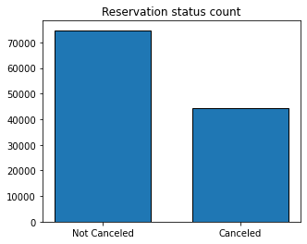

The accompanying bar graph shows the percentage of reservations that are cancelled and those that are not. It is obvious that are still a significant number of reservations that have not been cancelled. There are still 37% of clients who cancelled their reservations, which has a significant impact on the hotels’ earnings.

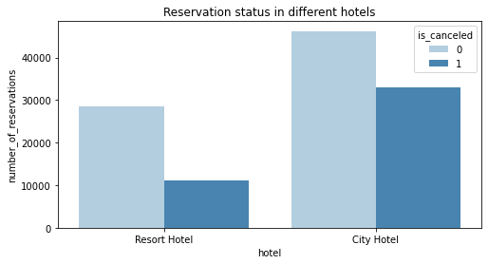

In comparison to resort hotels, city hotels have more bookings. It’s possible that resort hotels are more expensive than those in cities.

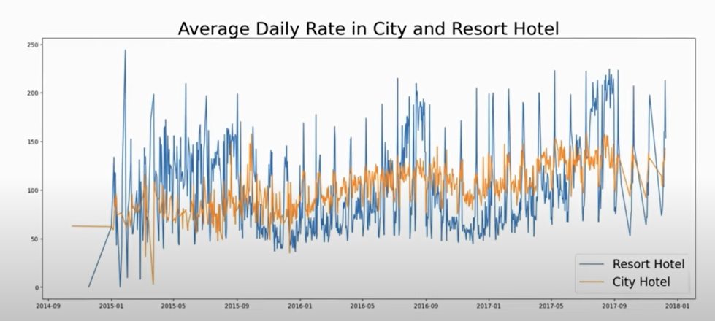

The line graph above shows that, on certain days, it is even less. It goes without saying than that of resort hotel, and on other days, it is even less. It goes without saying that weekends and holidays may see a rise in resort hotel rates.

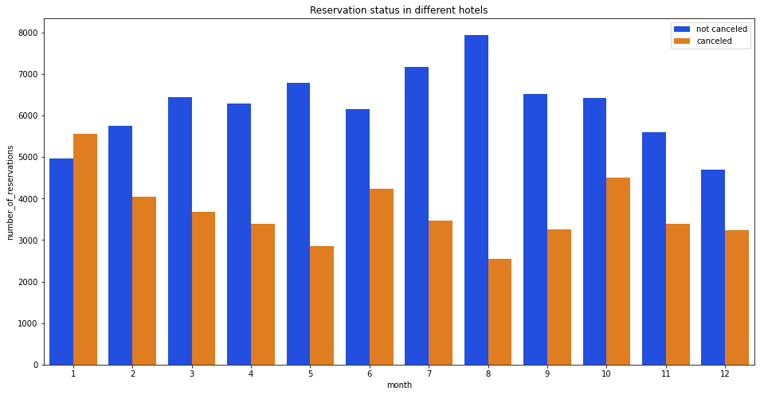

We have developed the grouped bar graph to analyze the months with the highest and lowest reservation levels according to reservation status. As can be seen, both the number of confirmed reservations and the number of cancelled reservations are largest in the month of August. Whereas January is the month with the most cancelled reservations.

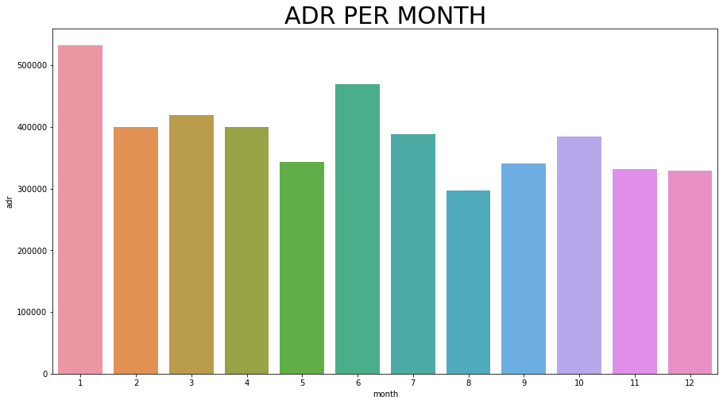

The bar graph demonstrates that cancellations are most common when prices are greatest and are least common when they are lowest. Therefore, the cost of the accommodations is solely responsible for the cancellation.

Now let’s see which country has the highest reservations cancelled. The top country is Portugal with the highest number of cancellations.

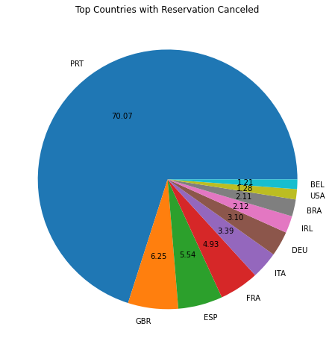

Let’s check the area from where guests are visiting the hotels and making reservations. Is it coming from Direct or Groups, Online or Offline Travel Agents? Around 46% of the clients come from online travel agencies whereas, 27% come from groups. Only 4% of clients book hotels direct by visiting them and making reservations.

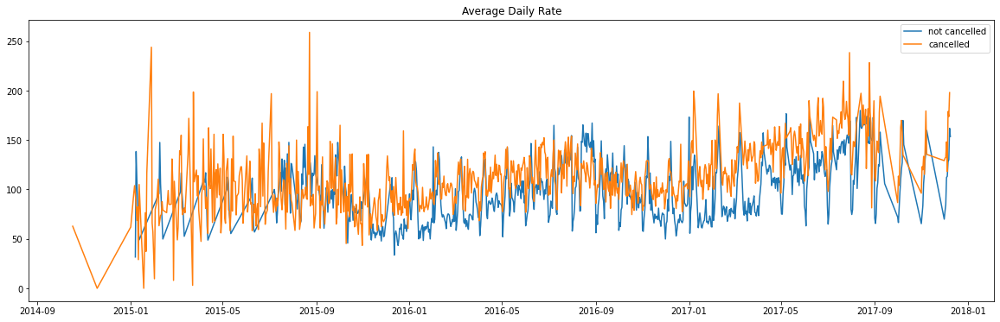

As seen in the graph reservations are cancelled when the average daily rate is higher than when it is not cancelled. It clearly proves all the above analysis, that the higher price leads to higher cancellation.

**Suggestions**

1. Cancellation rates rise as the price does. In order to prevent cancellations of reservations, hotels could work on their pricing strategies and try to lower the rates for specific hotels based on locations. They can also provide some discounts to the consumers.

2. As the ratio of the cancellation and not cancellation of the resort hotel is higher in the resort hotel than the city hotels. So the hotels should provide a reasonable discount on the room prices on weekends or on holidays.

3. In the month of January, hotels can start campaigns or marketing with a reasonable amount to increase their revenue as the cancellation is the highest in this month.

4. They can also increase the quality of their hotels and their services mainly in Portugal to reduce the cancellation rate.